Knowledge assessment quiz

    - Which of the following is a way to estimate LV systolic function on POCUS?
      - E-point Septal Separation
      - Myocardial thickening
      - Fractional shortening
      - All of the above

    - Which of the following lung ultrasound findings is true?
      - Presence of an A-line predominant pattern is helpful in ruling out an interstitial pulmonary process including pulmonary edema
      - Presence of a B-line predominant pattern (>3 B-lines) is helpful in ruling out an interstitial pulmonary process including pulmonary edema
      - None of the above

    - What is the most likely estimated LV based on the image below
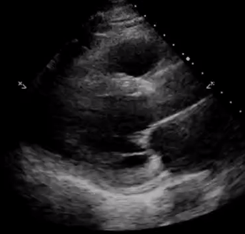
      - Likely preserved EF
      - Likely reduced EF

    - The red arrow in the image below is most likely pointing at a
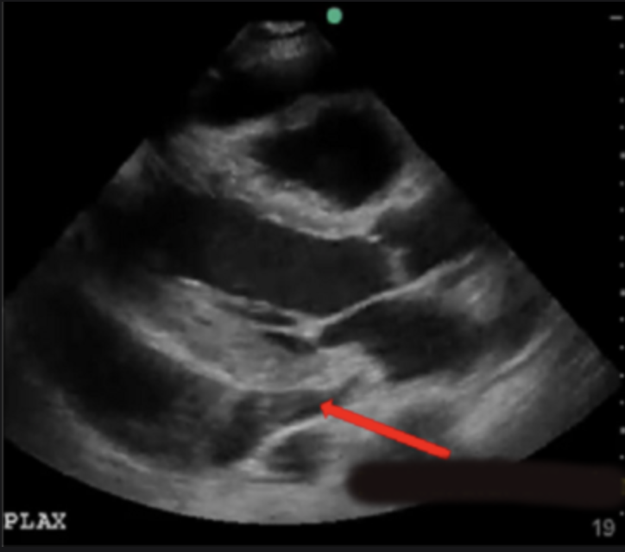
      - Pericardial effusion
      - Pleural effusion
      - None of the above

    - The white arrow in the image below is most likely pointing at a
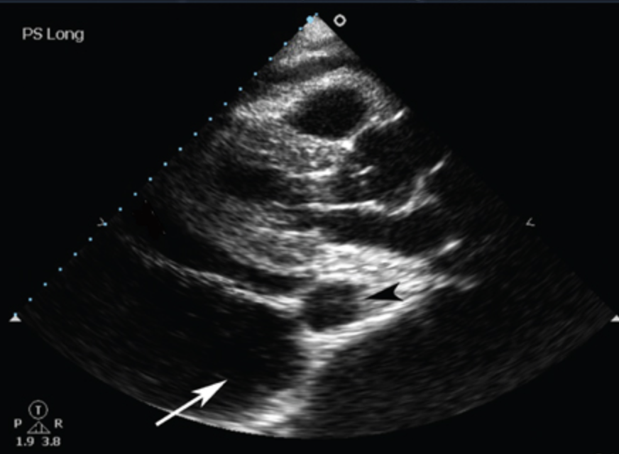
      - Pericardial effusion
      - Pleural effusion
      - None of the above

    - Which of the following statements about IVC and tamponade is true
      - Dilated IVC is a sensitive and specific finding in tamponade
      - Dilated IVC is a sensitive but not a specific finding in tamponade
      - Dilated IVC is a specific but not a sensitive finding in tamponade
      - Dilated IVC is neither a sensitive nor specific finding in tamponade

Pre-intervention survey

- I have utilized Point of Care Ultrasound on one of my patients myself
- Never
- Few occasions (<5)
- Some occasions (5-10)
- Frequently (>10)

- I have watched/directly observed one of my team members (a resident or attending) use Point of Care Ultrasound on one of my patients
- Never
- Few occasions (<5)
- Some occasions (5-10)
- Frequently (>10)

- I feel comfortable selecting the correct ultrasound probe and having the correct probe marker orientation when obtaining POCUS images (Parasternal Long, Apical 4 chamber, Subxiphoid, IVC)
- Extremely uncomfortable
- Somewhat uncomfortable
- Neither comfortable nor uncomfortable
- Somewhat comfortable
- Extremely comfortable

- I feel comfortable identifying major cardiac structures in specific cardiac ultrasound views - Parasternal Long, Apical 4 chamber and Subxiphoid
- Extremely uncomfortable
- Somewhat uncomfortable
- Neither comfortable nor uncomfortable
- Somewhat comfortable
- Extremely comfortable

- I can see the role that POCUS could have in undifferentiated shock* - (ie cardiogenic vs hypovolemic/hemorrhagic vs septic vs obstructive shock) (*assuming not a mixed shock presentation)
- I don’t see how it could be useful
- I can see how it could be useful but I am not sure about imaging findings
- I can see how it could be useful and I know the general imaging findings associated with the shock states listed above

- I feel comfortable identifying general/expected POCUS findings of a patient who is presenting with decompensated systolic heart failure
- Extremely uncomfortable
- Somewhat uncomfortable
- Neither comfortable nor uncomfortable
- Somewhat comfortable
- Extremely comfortable

- I feel comfortable identifying a large pericardial effusion with POCUS
- Extremely uncomfortable
- Somewhat uncomfortable
- Neither comfortable nor uncomfortable
- Somewhat comfortable
- Extremely comfortable

Immediate post-intervention survey

- How helpful was today’s SIM session
- Not helpful
- Somewhat helpful
- Very helpful

- How helpful was the educational material prior to today’s SIM session
- Not helpful
- Somewhat helpful
- Very helpful

- I feel comfortable selecting the correct ultrasound probe and having the correct probe marker orientation when obtaining POCUS images (Parasternal Long, Apical 4 chamber, Subxiphoid, IVC)
- Extremely uncomfortable
- Somewhat uncomfortable
- Neither comfortable nor uncomfortable
- Somewhat comfortable
- Extremely comfortable

- I feel comfortable identifying major cardiac structures in specific cardiac ultrasound views - Parasternal Long, Apical 4 chamber and Subxiphoid
- Extremely uncomfortable
- Somewhat uncomfortable
- Neither comfortable nor uncomfortable
- Somewhat comfortable
- Extremely comfortable

- I can see the role that POCUS could have in undifferentiated shock* - (ie cardiogenic vs hypovolemic/hemorrhagic vs septic vs obstructive shock) (*assuming not a mixed shock presentation)
- I don’t see how it could be useful
- I can see how it could be useful but I am not sure about imaging findings
- I can see how it could be useful and I know the general imaging findings associated with the shock states listed above

- I feel comfortable identifying general/expected POCUS findings of a patient who is presenting with decompensated systolic heart failure
- Extremely uncomfortable
- Somewhat uncomfortable
- Neither comfortable nor uncomfortable
- Somewhat comfortable
- Extremely comfortable

- I feel comfortable identifying a large pericardial effusion with POCUS
- Extremely uncomfortable
- Somewhat uncomfortable
- Neither comfortable nor uncomfortable
- Somewhat comfortable
- Extremely comfortable

- How can we improve today’s session and/or the educational material?
- < free text response option >

3-month post-intervention survey

- How helpful was the POCUS SIM session
- Not helpful
- Somewhat helpful
- Very helpful

- I have watched/directly observed one of my team members (a resident or attending) use cardiac POCUS on one of my patients
- Never
- Few occasions (<5total)
- Some occassions (5-10)
- Frequently (>10)

- I have utilized cardiac POCUS on one of my patients myself
- Never
- Few occasions (<5total)
- Some occassions (5-10)
- Frequently (>10)

- I can see the role that POCUS could have in undifferentiated shock* - (ie cardiogenic vs hypovolemic/hemorrhagic vs septic vs obstructive shock) (*assuming not a mixed shock presentation)
- I don’t see how it could be useful
- I can see how it could be useful but I am not sure about imaging findings
- I can see how it could be useful and I know the general imaging findings associated with the shock states listed above

- I feel comfortable identifying major cardiac structures in specific cardiac ultrasound views - Parasternal Long, Apical 4 chamber and Subxiphoid
- Extremely uncomfortable
- Somewhat uncomfortable
- Neither comfortable nor uncomfortable
- Somewhat comfortable
- Extremely comfortable

- I feel comfortable selecting the correct ultrasound probe and having the correct probe marker orientation when obtaining POCUS images (Parasternal Long, Apical 4 chamber, Subxiphoid, IVC)
- Extremely uncomfortable
- Somewhat uncomfortable
- Neither comfortable nor uncomfortable
- Somewhat comfortable
- Extremely comfortable

- I feel comfortable identifying general/expected POCUS findings of a patient who is presenting with decompensated systolic heart failure
- Extremely uncomfortable
- Somewhat uncomfortable
- Neither comfortable nor uncomfortable
- Somewhat comfortable
- Extremely comfortable

- I feel comfortable identifying a large pericardial effusion with POCUS
- Extremely uncomfortable
- Somewhat uncomfortable
- Neither comfortable nor uncomfortable
- Somewhat comfortable
- Extremely comfortable

- How can we improve today’s session and/or the educational material?
- < free text response option >

- In which ways, if any, was the POCUS SIM session beneficial for you?
- < free text response option >

- How can we improve the POCUS SIM session and/or the educational material?
- < free text response option >

